**Power BI**

**Power BI** is a business analytics tool developed by Microsoft that helps you **visualize data, create reports, and share insights** easily. It connects to various data sources (like Excel, databases, or online services), organizes the data, and lets you create **interactive dashboards** and reports.

**Step 1** : Download **Power BI.**

**Link:** [Download Microsoft Power BI Desktop from Official Microsoft Download Center](https://www.microsoft.com/en-us/download/details.aspx?id=58494)

After open Power BI then shows welcome window of power BI :

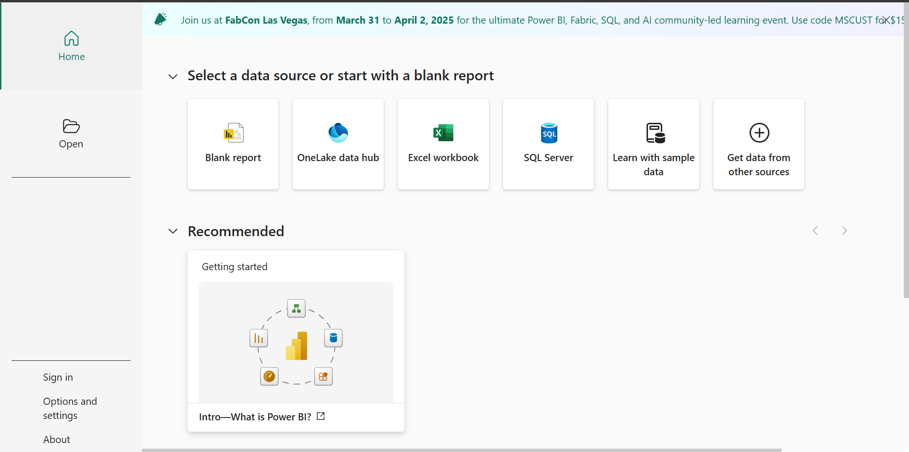

After Clicking Blank report this window is called as Power BI Desktop:

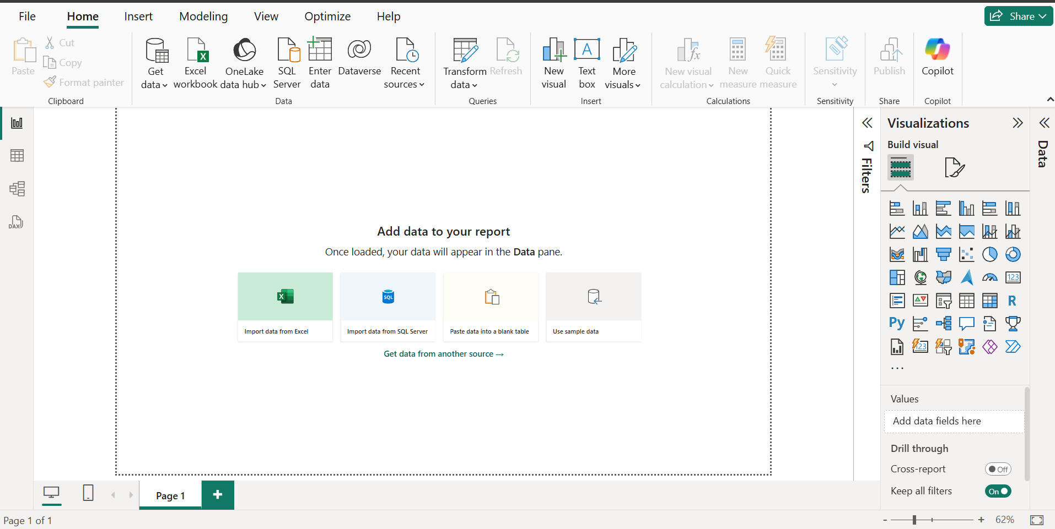

- Inside desktop in right side show visualizations

- Mid area is called as canvas

After Clicking Get data then shows options :

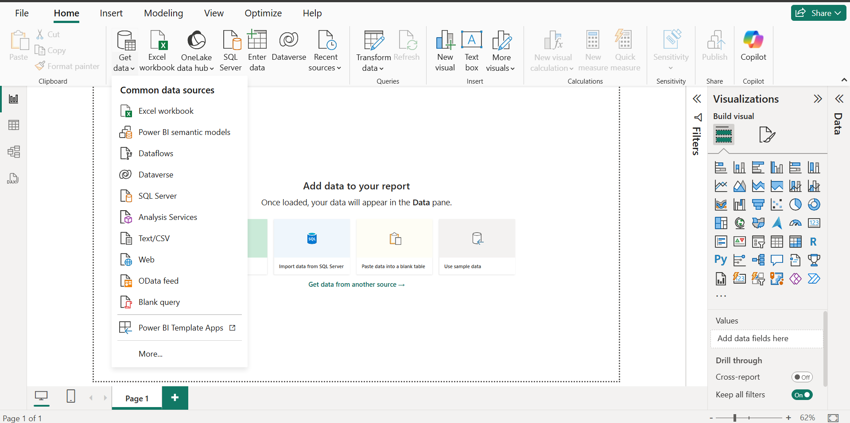

Choose csv file

- A **CSV file** (Comma-Separated Values) is a simple text file used to store data in a structured format, like a table.

-Example of a CSV file:

Name, Age, City

John, 25, New York

Emily, 30, London

Raj, 28, Mumbai

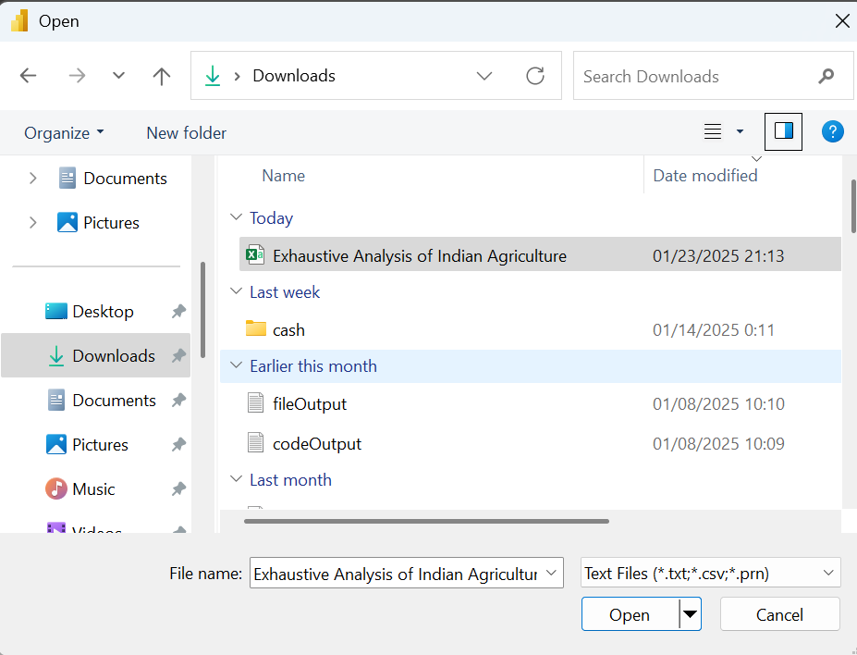

Click in open then shows this window :

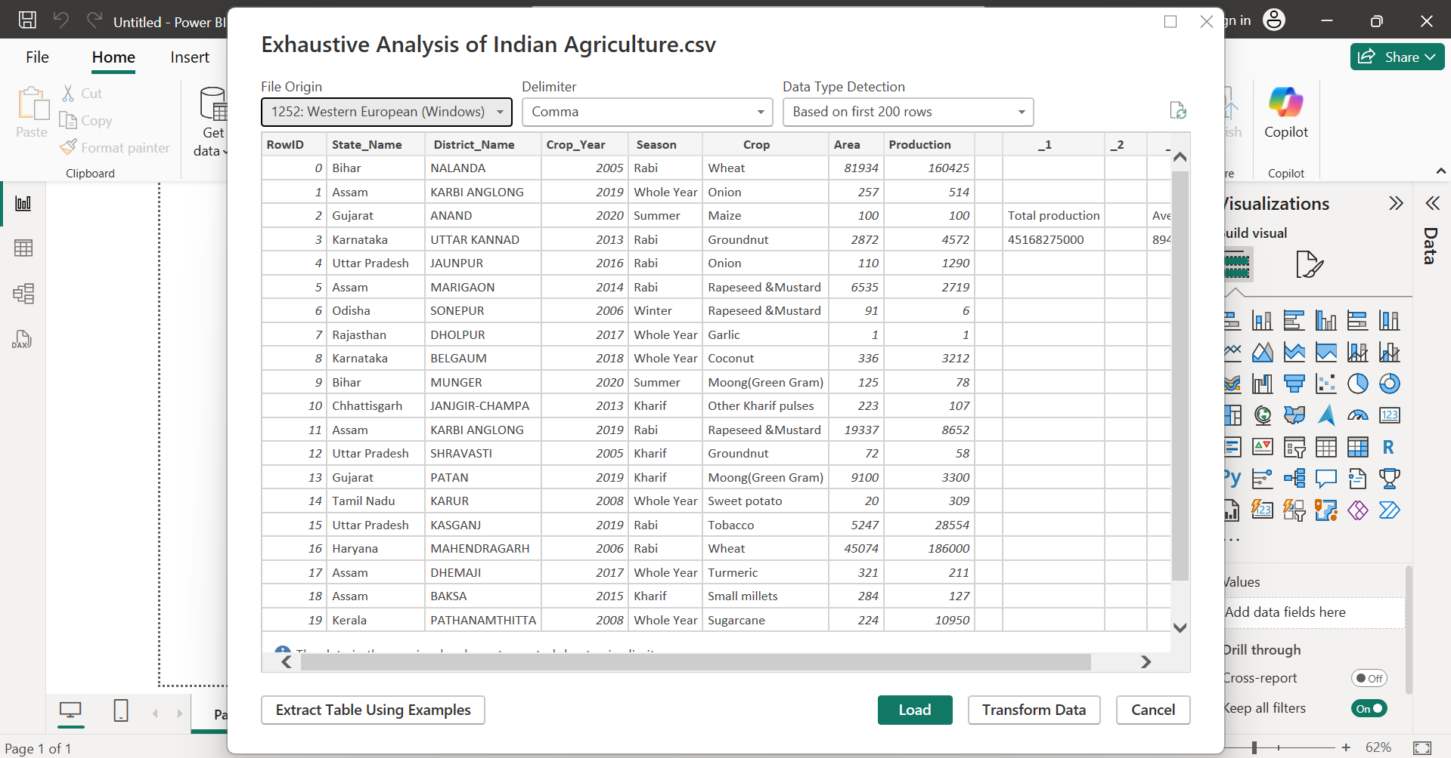

-In this window shows in right corner in three buttons:

1. Load – then click on load when data is cleaned.

2. Transform Data - then click on Transform Data when you want to process the data.

3. Cancel-there are not perform any operation.

Click load then load then shows window:

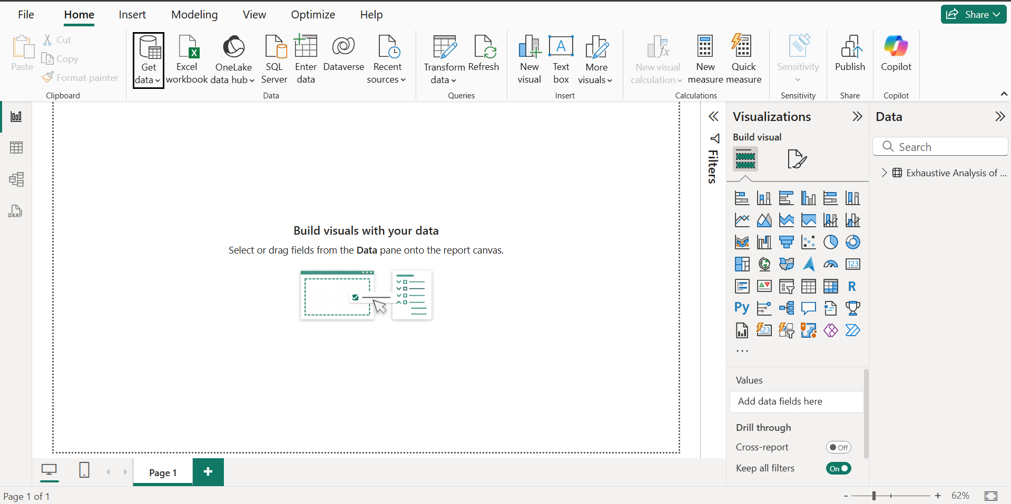

* In right side to show file to loaded
* In left side to shows four icons:

1. Report view : performs all the visualizations.
2. Table view :get the over view in data or show data in tables.
3. Model view : so we can create relationship among data.
4. DAX query view

In top side in queries inside show option Transform data then Clicking Transform data then show:

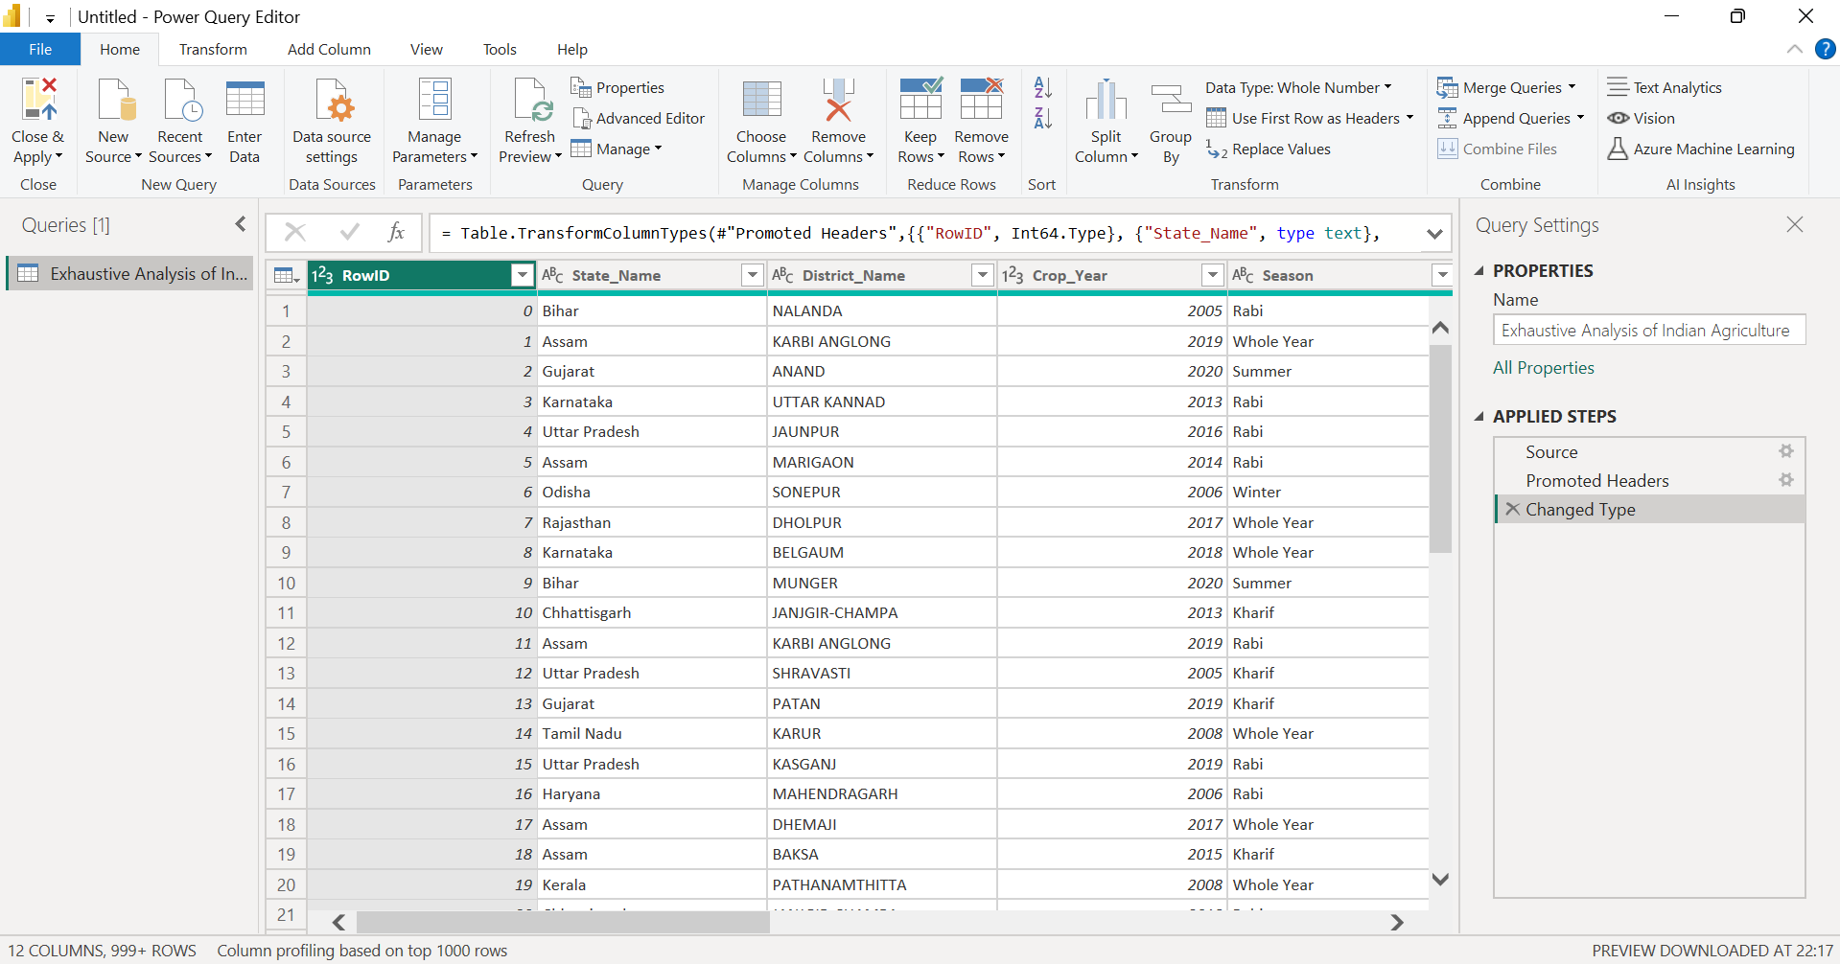

* this is also called as power query editor
* with the help of this windows to perform all the transformation

there are also show blank column in this file this is do not help then remove the columns to follow procedure:

1. Click any column you want to delete
2. Then click right button then show this:

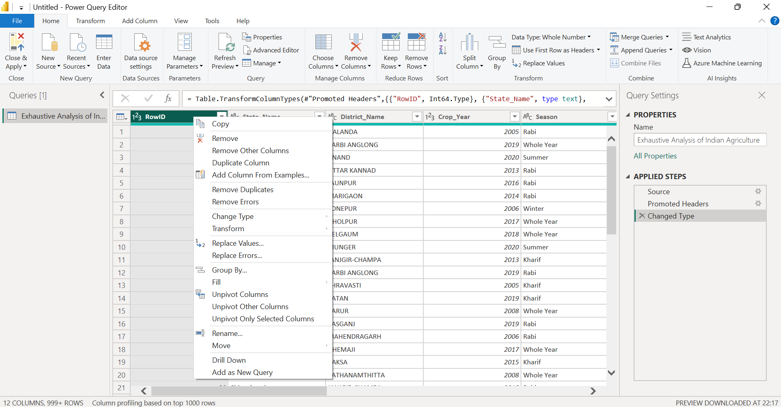

Then click remove option then remove column

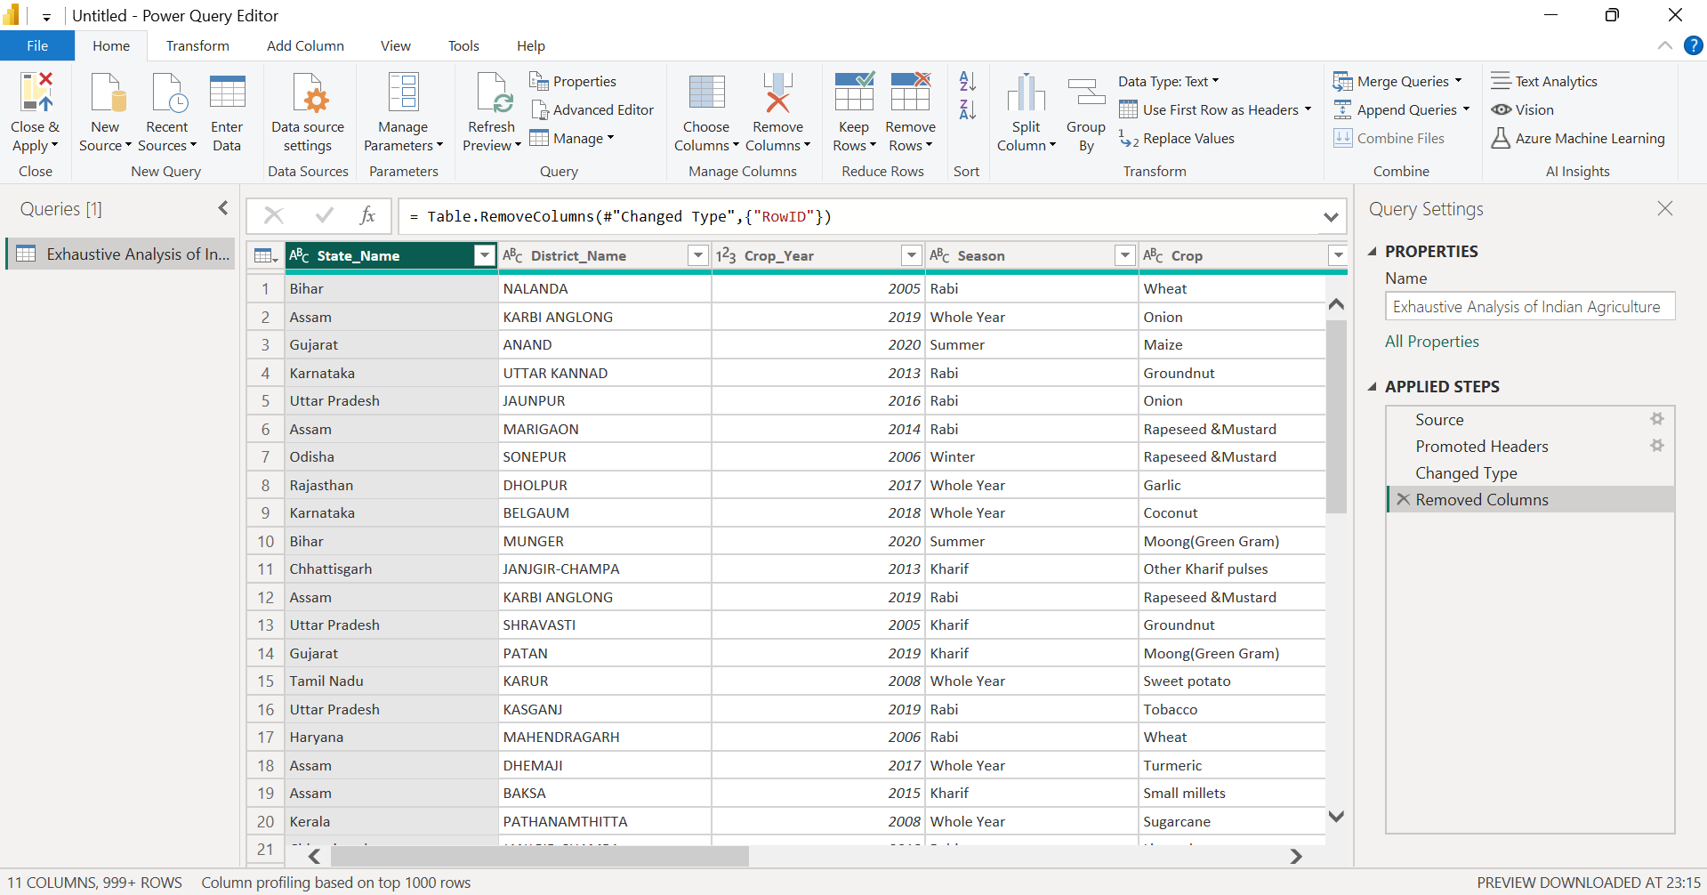

You want to retrieve the column then right side to show removed columns

After clicking removed columns then:

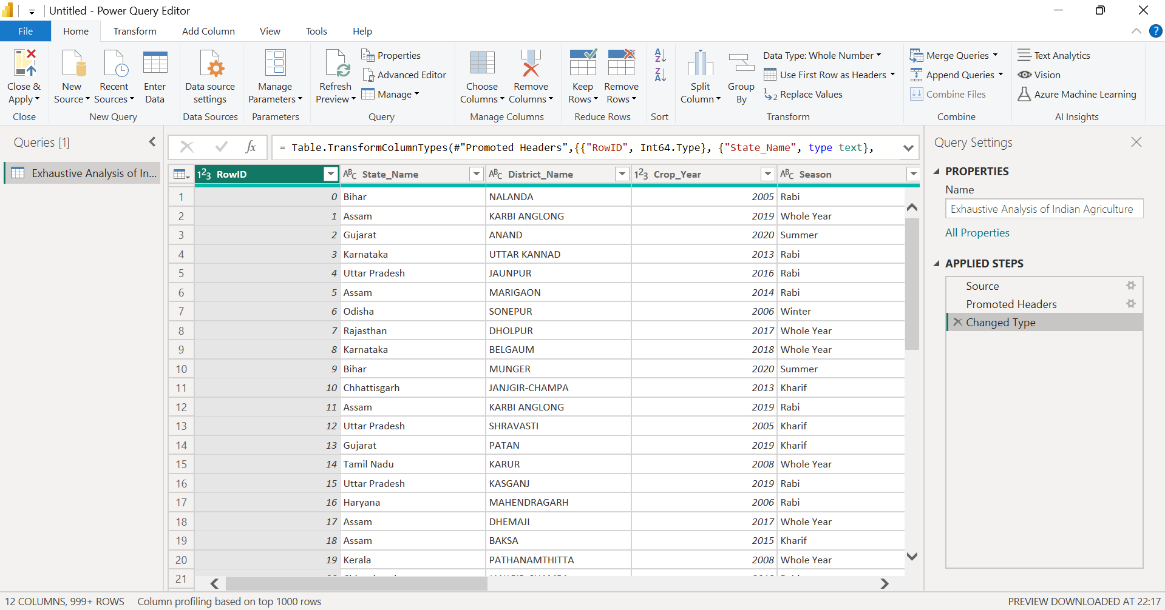

Similarly to remove all unnecessary columns .

If you want to see null values then click in view and check column quality:

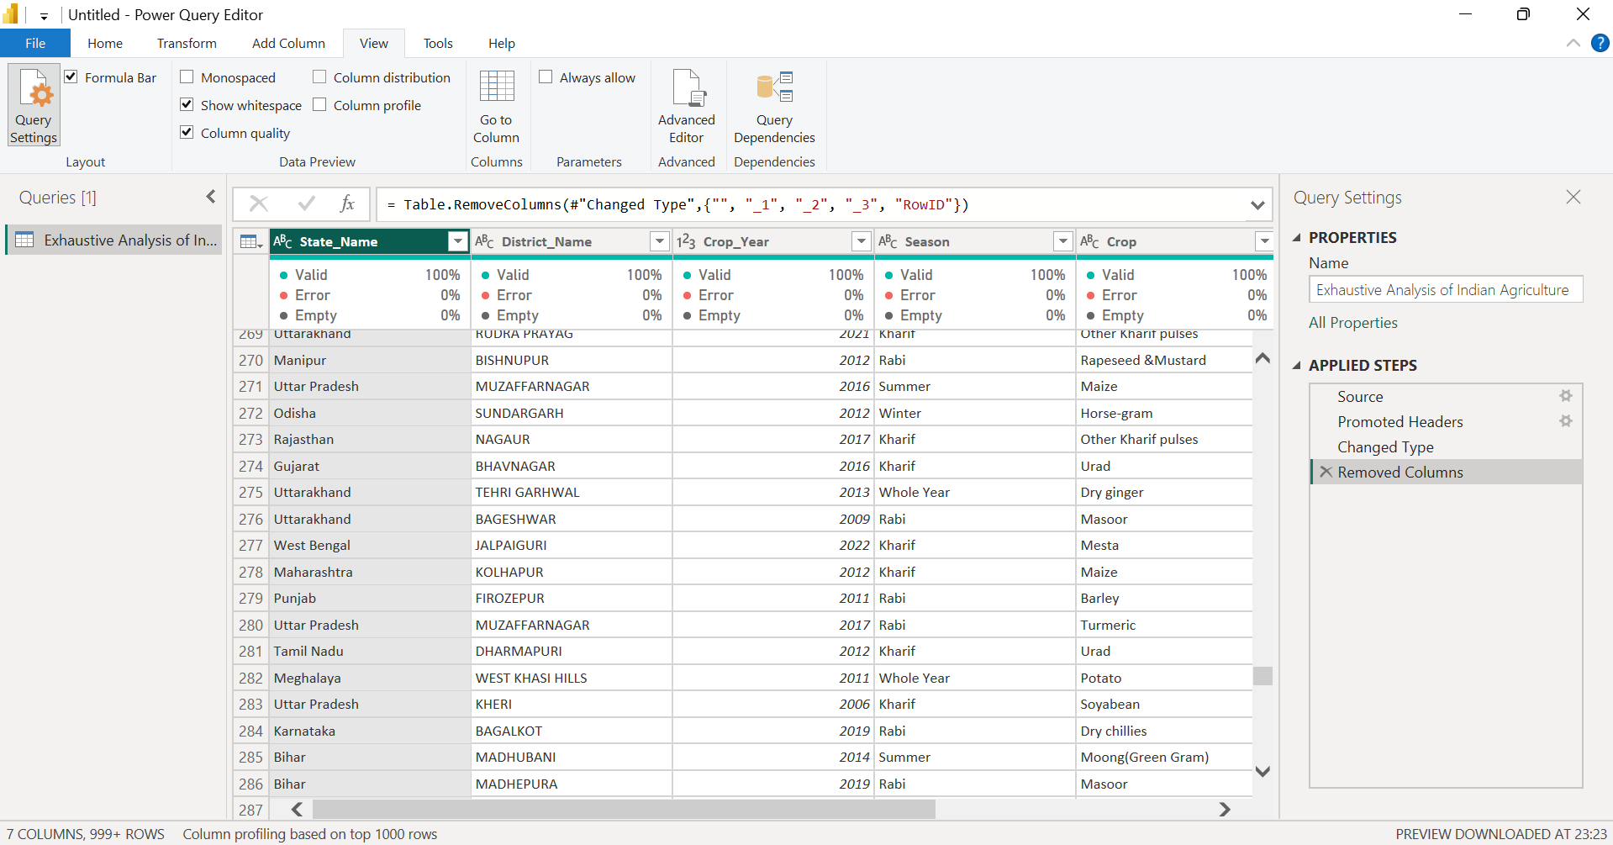

If you want to remove rows for duplicate or null values then click home then click Remove rows and select the option you want to:

